Southland Plantation Forest Company of New Zealand management plan SUMMARY 2021

  - Prepared by Southwood Export Limited, April 2021

Contents
1. Introduction 3
2. Company Profile 4
3. Management Objectives 4
4. Forest Resource 4
5. Silviculture 6
6. Monitoring Forest Growth and Dynamics 6
7. Harvesting 7
8. Stakeholder Summary 7
9. Environmental 7
9.1 Wilding Control 8
9.2 Reserve Management 8
9.3 Riparian Management 8
10. Identification and Protection of Rare, Threatened and Endangered Species 9
10.1 Rare, Threatened and Endangered Species 9
10.2 Significant Conservation Areas 9
11. Pest and Weed Control 9
12. Health and Safety 10
13. Environmental and Social Impacts 10
14. Forest Health Assessment 10

Introduction
This document is a summary of the SPFL Management Plan for its forests which are certified by Forest Stewardship Council (FSC).
FSC certification is an internationally recognised standard that demonstrates how forests are managed in an environmentally sound, socially beneficial, and economically viable manner. SPFL initial FSC certification was granted in 2004 through measurement of its operations and practices against the Principles and Criteria developed by FSC which define well managed forests.
Principle 7 of FSC requires SPFL to develop a management plan.
Principle 10 of FSC requires SPFL to explicitly state in the management plan the management objectives of the plantation, including natural forest conservation and restoration objectives, and which are clearly demonstrated in the implementation of the plan.
The Principles state
Principle 7: Management Plan- A management plan- appropriate to the scale and intensity of operations-shall be written, implemented, and kept up to date. The long term objectives of the management, and the means of achieving them, shall be clearly stated”
Principle 10.1.1: Objectives of tree planting shall be explicit in the management plan, with clear statements regarding the relationship between tree planting and the silviculture, socioeconomic and environmental (i.e. forest conservation and restoration) realities in the region.
Principle 10.1.2: Management objectives for conservation of natural forest and restoration shall be described in the management plan.
Principle 10.1.5: Plantation management objectives, including explicit measures under Criteria 6.2, 6.3, 6.4, 6.9, 6.10, 10.2 and 10.5 intended to maintain and retain indigenous biodiversity, are identified in the management plan and implemented in a timely manner.
Principle 10.1.6: The management plan shall identify the boundaries of the area encompassed by the certificate, which includes the plantation forest plus any designated reserve areas.
This plan is in fulfilment of Principle 7 and the relevant criteria of Principle 10.
This document describes the higher level policies for the SPFL estate under the SPFL Certificate RA-FM/COC-1130.

Company Profile
Southland Plantation Forest Company of New Zealand Limited (SPFL) is a private company, registered in New Zealand, with its owners based in Japan. The company was formed in 1991 to establish Eucalypt forests to provide a hardwood fibre resource for Oji Paper Company of Japan. All forests are located within Otago /Southland, and forests are grown on a renewable and sustainable basis. To reduce impacts on any small rural area, the forests are scattered throughout the region. The company has its office based in Invercargill at the following address:
45 Kekeno Place
P O Box 7010
Invercargill 9844
Ph: (03) 214 1912
Fax: (03) 218 2066

Management Objectives
The primary purpose of the SPFL estate is to provide a sustainable supply of hardwood fibre to the pulp and paper mills of its shareholders in Japan. The choice of specie/s must be ‘fit for purpose, the addition of an alternative specie/s must compliment this purpose and add benefits.
The forest management plan is to provide for high yielding crops on the most economic basis while remaining fully compliant with National & Regional legislation and in doing so create benefits for the community. The opportunity to add value to the project is always a target.
SPFL has appointed Southwood Export Limited (SWEL) to manage its Estate.

Forest Resource
All of SPFL’s forests are within 120km of Invercargill (Figure 1). A table of areas is provided to give a summary of the areas owned or occupied by SPFL, their tenure and land use (Table 1). The SPFL estate currently comprises forty-two individual areas of mixed age forests totalling approximately 10,670 ha. The plantings are mostly E.nitens (99%); the remaining crop is made up of mixed conifers.
The land is mostly owned by the Southland Plantation Forest Company, three Properties are under a lease agreement. The majority of properties are established on previously farmed land, some include exotic plantation cutover sites.
The lands are mostly located in the Plains Resource Area as described in the District plans. The management plan will ensure that all activities are compliant with requirements of the District Plans.

Figure 1 Map of SPFL Forest Estate, Southland
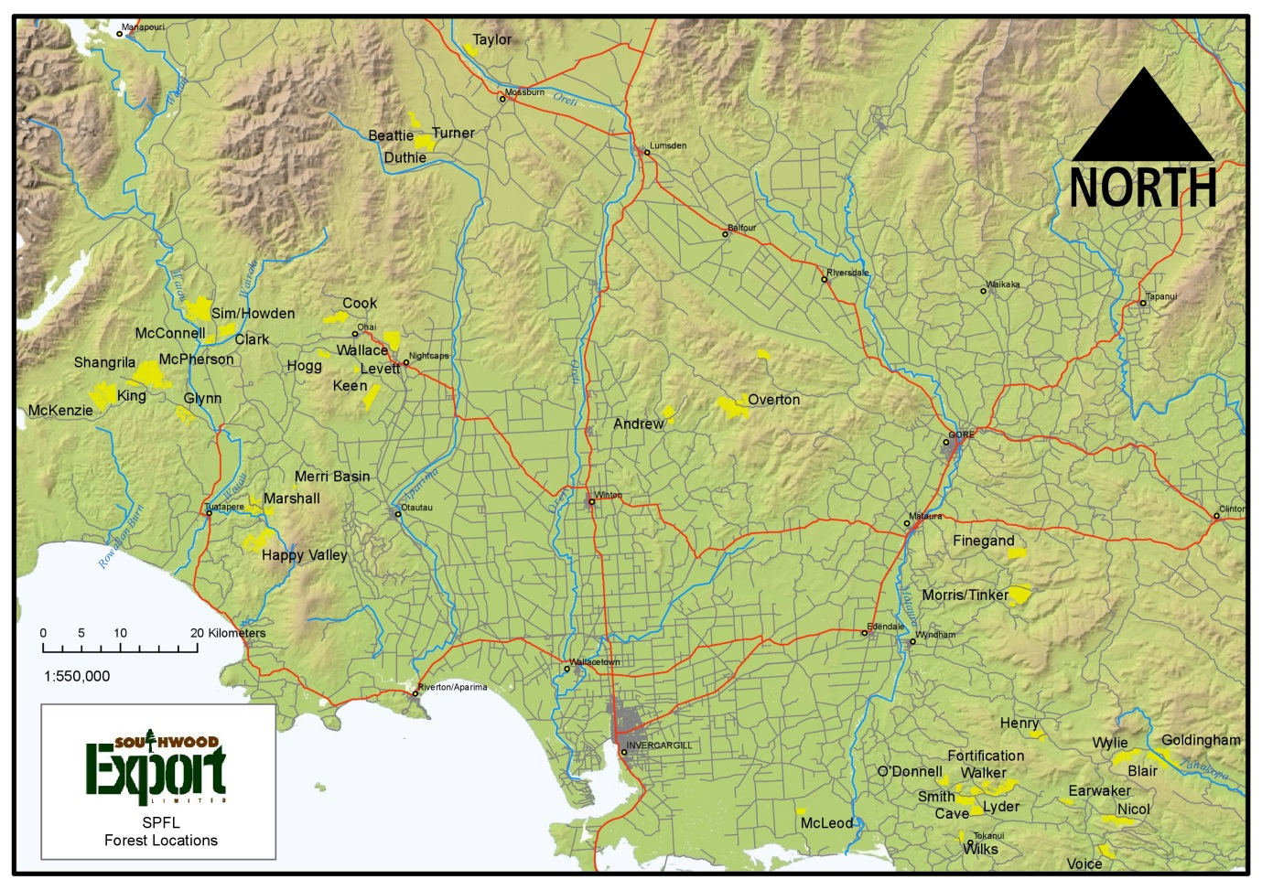
Table 1: SPFL Estate Area Summary as at 4 June 2020

Forest Ownership | Forest Count | Area (ha)
 |  | Stocked | Landbank | Non-productive | Total
SPFL | 42 | 9,621.98 | 1,075.72 | 3,228.7 | 13,926.4

Silviculture
The major determinates of tree growth are climate and soils. Research has identified some eucalyptus species have a high tolerance for Southlands cooler conditions, with a likening for clays and moist loams and very good frost tolerance. The New Zealand Forest Service trialled many species of Eucalypts in Southland, species deemed to be appropriate for the conditions include E. delegatensis, E.regnans and E.nitens. Southlands mild summer temperatures, consistent summer rainfalls, and low evapotranspiration rates are particularly ideal for growing E.nitens.
The forests are currently grown on a nominal 15 – 18+ year rotation to produce hardwood fibre. Improved genetics & growth leading to better wood qualities, together with advances in technology in wood handling & processing will lead to other market opportunities. Investigation into this is ongoing and will likely require changes to the silviculture regime going forward.
The current regime for SPFL’s forests is plant a well-spaced and uniform crop. The common stocking for the first rotation was 1050 stems per hectare. With the benefit of subsequent research the second crops are being planted at 800 – 900 stems per ha (varies with site). Intensive land preparation is carried out during establishment including cultivation, weed removal and fertilising.
The actual rotation age of each stand can vary for a variety of reason which include market demand, total recoverable volume per hectare, piece size, topography and harvesting economics and may exceed the target age. Any future change to silviculture treatments will likely influence the rotation length also. The net result will be a developing matrix of differing age classes over subsequent rotations.
SPFL is committed to ongoing research and development into improving forest genetics and growth through research providers such as Scion.

Table 2: SPFL Estate Silvicultural Operations Summary 2020
Operation | Total (ha)
Re-establishment | 768
New Planting | 0
DAP Hand Fertilising | 768

Monitoring Forest Growth and Dynamics
Growth and yield information plays an important role in forest management. Growth is monitored from planting with PSP’s established at age 5.
PSP’s are established at a frequency of 1 plot per 50 ha and are used to calibrate our Euc Growth Model.
A range of trials have been carried out about management practices and increased growth in the past. Included in these trials are fertiliser, thinning and species trials. Tree nutrient levels have been monitored by means of foliage sampling. This in conjunction with tree canopy assessment give a good indication of expected tree growth going forward. The management company (SWEL) in conjunction with other research providers has access to the latest growth and yield calculators and growth models.
SWEL operates a quality control system whereby all work that is carried out by Contractors is supervised and assessed to make sure that the company health and safety requirements as well as the quality requirements are being fulfilled.

Harvesting
The current year’s level of harvesting is 355,000m3/year from mechanised clear-felling with an average clear-fell age of 20 years to meet market demand of 168,000 bone-dry tonnes (BDT) per year. Future projections show our sustainable cut may be reduced if the average harvest age class has been pulled back to about 17/18 years, this is subject to a review following latest growth and actual forest products outturn figures across all forests from actual harvest returns.
For the period April 2020 – March 2021 approximately 500 ha will have been clear-felled consisting primarily of E.nitens, using ground-based mechanised harvesting and forwarding system.

Stakeholder Summary
SWEL engages mostly local contractors to carry out the day-to-day forest operations within the SPFL forest estate. Work includes establishment, harvesting, log and chip cartage, processing, ship loading and general forest operations in SPFLs forest estate. Numbers vary with seasonal variability but can exceed 108 people at peak times.
SWEL operates a comprehensive Drug & Alcohol free H&S policy for all worksites.
A number of individual recreational permits have been granted for SPFL forests primarily for hunting access over the last 12 months.

Environmental
SPFL is dedicated to protecting and enhancing where possible, biological diversity and ecosystem values. Regular monitoring of environmental parameters of forests will be undertaken to ensure that the effects of both natural and man-made events are minimised.
Mission Statement: To preserve and maintain the ecologically significant areas, while maintaining good economic management practices within forests.
SPFL has an Environmental Management System (EMS) in place. It incorporates an Environmental Incident Procedure, Heritage Site Management, Riparian Management and Monitoring Strategy. The EMS covers consents and permits, both internal and external communication and incorporates an audit and review process. It is a comprehensive system to encourage a high standard of environmental performance.

Wilding Control
There has been no evidence to show a wilding problem with Eucalyptus. The seed of E.nitens has a gravity dispersal system in that it falls directly down from the parent tree; its seed is not dispersed by wind or animals.
There are small areas of other species of the conifer family which could have a wilding spread risk. These are small areas of P.radiata and P.menziesii . These would be assessed using the Wilding Tree Risk Calculator required by the National Environmental Standard for Plantation Forestry.

Reserve Management
All areas of current reserves within SPFL’s forests have been identified, mapped and their importance listed, and any rare, threatened or endangered flora and fauna identified. There is more information about reserves available (entitled ‘Reserve Management’) and a GIS mapping layer available on the GIS System in SWEL’s office.
The Reserve Areas have been selected after a coarse level survey was carried out on all unplanted areas within the current estate. From this, individual areas were matched to ecological types. Areas that are currently under some form of legal protection (e.g. covenant) have reserve status. Other reserve areas have been selected as a result of an ecological survey, and interest or notification from stakeholders.
Other areas may attain reserve status in future if it is determined they contain ecologically important species or for some other significant reason. Further surveys to monitor the health of selected indigenous reserve areas are carried out periodically.

Riparian Management
The objective of riparian management is to ensure that SPFL’s forestry operations are not having a detrimental effect on riparian habitats/reserves or stream health. The management of riparian areas will be conducted along the guidelines set by the Southland District Plan, the New Zealand Environmental Code of Practice for Plantation Forestry and the Principles of FSC. The National Institute of Water and Atmospheric Research (NIWA) provide a stream health monitoring kit. This has been used at selected representative sites for field sampling and continually monitoring the health of our waterways. Fieldwork is carried out by SWEL staff using the stream health monitoring kit and a stream health report is produced periodically. The stream monitoring plots show healthy levels of turbidity and generally good stream health with turbidity levels hovering around the 80% clarity mark.

Identification and Protection of Rare, Threatened and Endangered Species

Rare, Threatened and Endangered Species
SPFL has identified the reserves in conjunction with local ecologist (Lloyd Esler) and liaison with DOC staff that have or are likely to have RTE species present and likely to be encountered. Focus of the RTE species management plan will concentrate on these areas with the possibility of adding more forest reserves to the list in future if the need is identified. Reserve areas are monitored / reassessed every 5 years for signs of degradation due to pests and weeds.
RTE species are important to SPFL and therefore they are always taken into consideration when planning and carrying out operational activities. A brochure is given to all staff and contractors highlighting several RTE species that may be found in the area. Should any further RTE species be discovered, the species is registered within our system and appropriate management plans are put in place. The most commonly recorded RTE species by staff and contractors is the NZ Falcon. From time to time, as required, forest harvesting or land disturbance operations are delayed to allow falcon to nest uninterrupted. Areas containing RTEs are demarcated on harvest planning maps, GIS, and on the ground, where necessary, for exclusion.

Significant Conservation Areas
Within the SPFL estate there are three areas that can be classed as significant conservation areas. These are:
- Overton Forest: 206.6ha of QEII Covenant
- Happy Valley Forest: 190ha of DOC Covenant
- Blair Forest: Blair Fen, Regionally Significant Wetland (Otago Regional Council)
Located within Blair Forest is the Blair Swamp and Blair Fen. These wetlands are protected by the Resource Management Act via the Otago Regional Council. Any modifications to this environment require a Resource Consent.

Pest and Weed Control
SPFL’s policy in relation to Integrated Pest Management is the control/management of both animal and plant pests by using methods which have the desired effect in controlling the pest while also having regard to minimising any negative effect it may have on the environment.
It is essential that in the establishment of plantations that specific establishment methods relating to the species being grown are adopted. SPFL are primarily involved in establishment of Eucalyptus nitens, which has associated plant and animal pests, which in some cases are selective to the species and need to be controlled to allow for effective establishment.
The aim is to obtain information on options available in controlling pests, selecting the most appropriate option to control the pest while taking due care to minimise any adverse effect on the environment but still achieve effective control.
SWEL/SPFL’s policy is that all pest control, both agrichemical/non agrichemical be applied with careful consideration given to:
- Application effectiveness and accuracy
- Rates of product kept to minimum to perform task
- Safety aspects adhered to, prior, during and following the operation
- Is the product selected the best option considering effectiveness and environmental effect.
- Have other alternatives been considered
All operations are to be compliant with the local authority requirements and meet the standards set down in the Code of Practice for the Management of Agri Chemicals NZS 8409:2004.

Health and Safety
SPFL/SWEL is committed to ensuring the Health and Safety of all employees, contractors and their employees, sub-contractors and their employees and visitors to avoid work related injuries. The safety of all personnel is paramount to SPFL’s operations, incident reports are used to identify the incidents and actions taken that will improve the health and safety of the employees/contractors.
As part of Health and Safety monitoring, SPFL/SWEL requires prospective and current employees/contractors to undergo drug and alcohol tests.

Environmental and Social Impacts
Forestry activities have environmental and social impacts. In order to reduce business risk and to maintain good relationships with the neighbouring community, SPFL/SWEL gives prior notice to potentially affected stakeholders of the operations to be undertaken such as harvesting, aerial weed and pesticide spraying, land preparation, planting and fertilising.

Forest Health Assessment
Forest health monitoring surveys are important to identify any health issues in the growing trees. This year numerous ground surveys took place to monitor Eucalypt Tortoise beetle damage.

